**Chapter-20** [***Miscellaneous***](https://www.google.com/search?sca_esv=255434547640be12&sca_upv=1&q=Miscellaneous&spell=1&sa=X&ved=2ahUKEwjcgoW_tI-HAxVvUGwGHUPwAdcQkeECKAB6BAgLEAE) *topics*

**GraphQl:**

GraphQL is a query language for APIs and a runtime for executing those queries with your existing data. It was developed by Facebook and publicly released in 2015. Here are some key aspects of

Overall, GraphQL provides more flexibility, efficiency, Single Endpoint and a better developer experience compared to traditional RESTful APIs, especially in scenarios where clients require precise control over the data, it also increase the execution performance

EG :

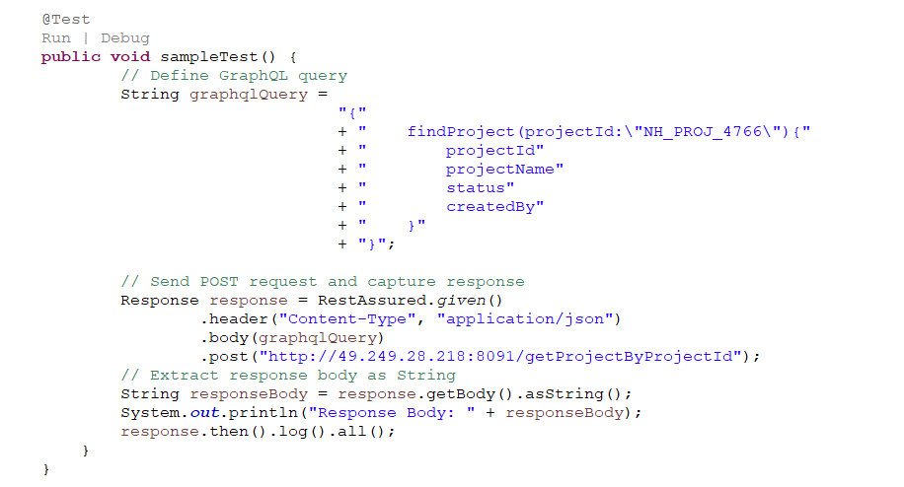

Eg: 2

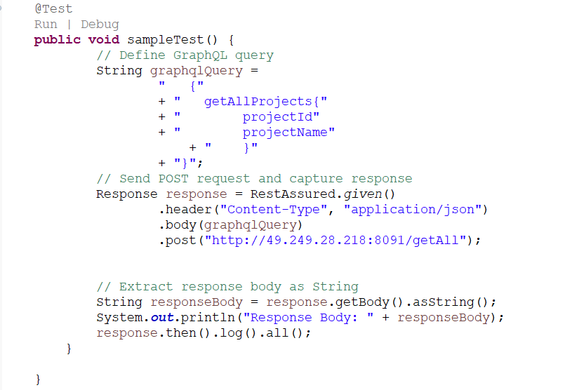

Sample GraphQl

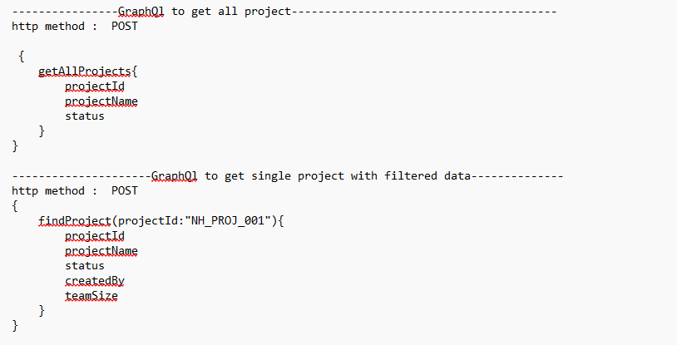

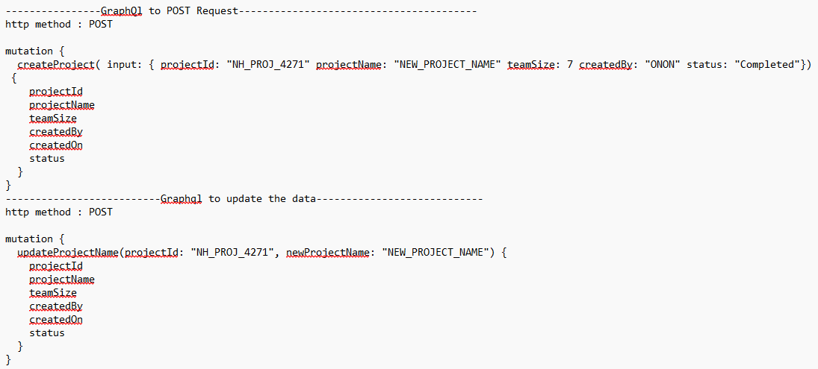

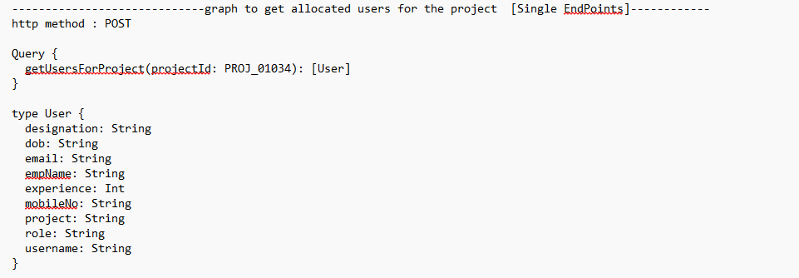

**URL Encoding**

RestAssured simplifies URL encoding by automatically handling it for most cases involving query parameters and path segments. However, for more complex scenarios or when encoding values manually is necessary, Java's URLEncoder

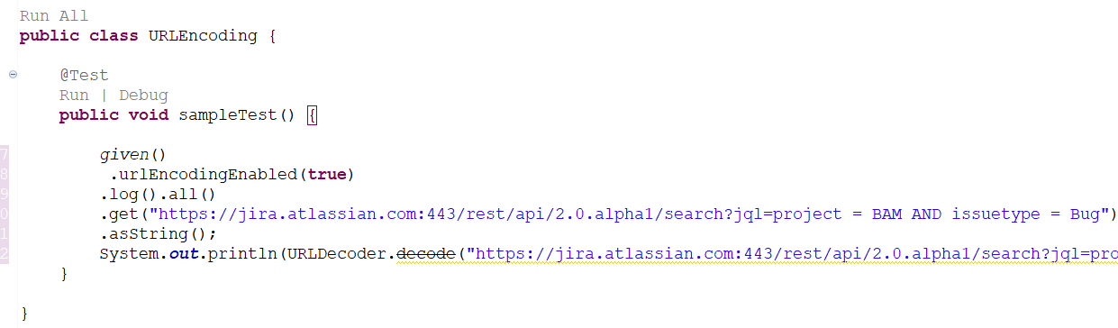

**JSON Schema validation**

RestAssured primarily focuses on testing RESTful APIs and verifying their responses against expected criteria. Schema validation, however, typically involves validating the structure and data types of JSON or XML responses against a predefined schema

How to get the JSON schema

1. Execute RestAPI Request
2. Copy the response body from the execution console
3. Go to URL : <https://jsonformatter.org/json-to-jsonschema> as below
4. Copy the schema from the website and save it in a file

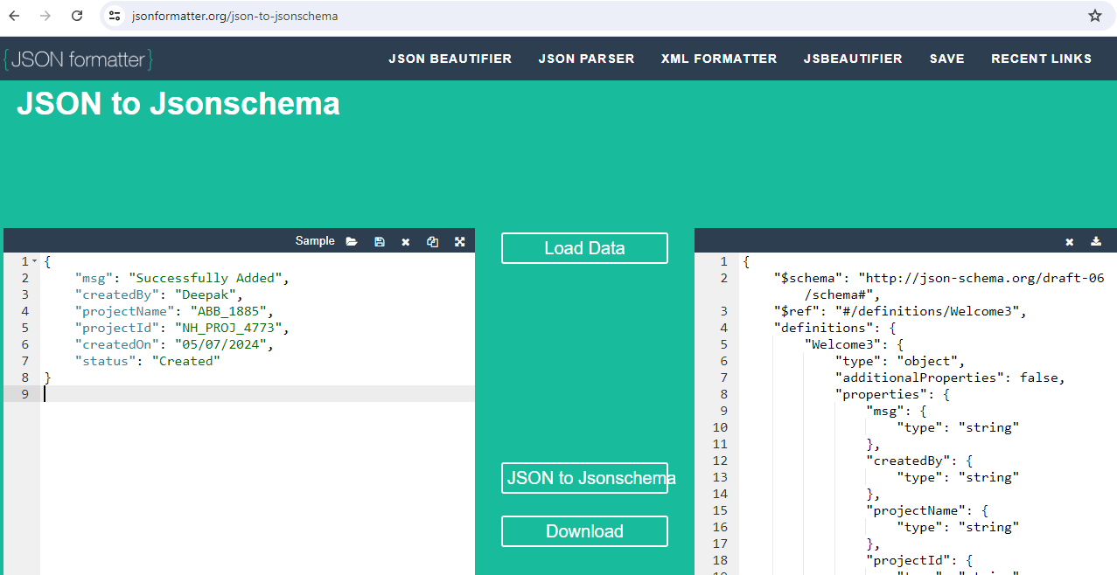

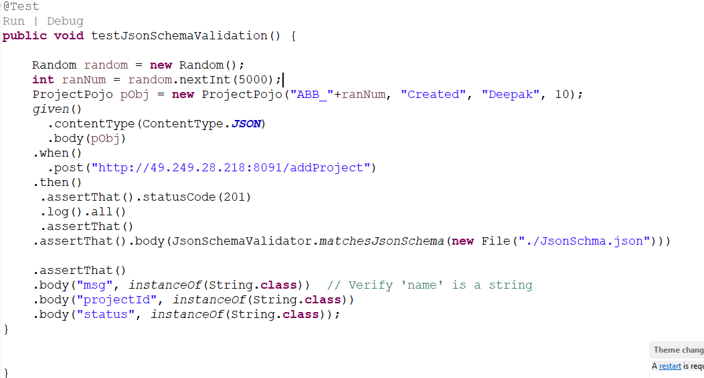

**Cookies :**

Cookies are small pieces of data sent by the server to the client and then returned by the client with every subsequent request to the same server. They are primarily used for session management, user authentication, and track

